DR. AMBEDKAR COLLEGE, DEEKSHABHOOMI, NAGPUR,

DEPARTMENT OF LAW
ACADEMIC SESSION 2022-23
NAME OF PROGRAMME: | Women’s Day Celebration 2023
DATE AND DAY: | 8th March 2023
TIME: | 11.30 am to 2.30
VENUE: | Seminar hall, Department of Law
Co-ordinator | Dr. S.P. Kalamdhad
Co- Co-ordinators | Dr. Vaishali A. Sukhdeve,  Ms. Sarika Kamdi, Ms. Anusha Patre.

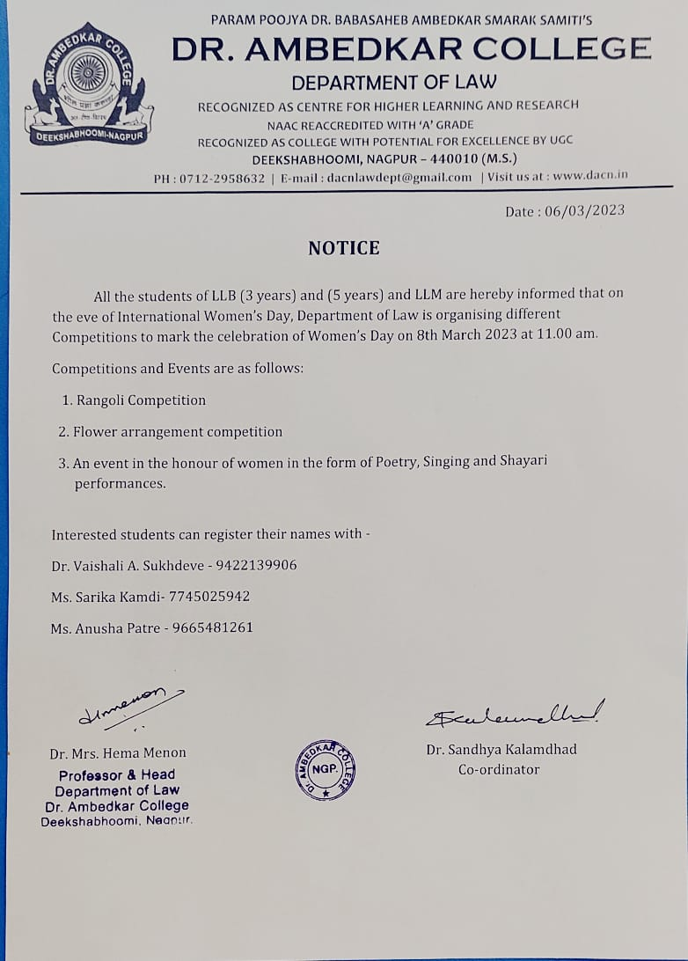
REPORT
The International Women’s Day was celebrated on 8th March, 2023 in the Department of Law, Dr. Ambedkar College, Deekshabhoomi, Nagpur. The students of LLB 3 Years, 5 Years and LLM actively participated in the different non-academic competitions organized by the Department to mark the women’s day. Competitions and Events included were Rangoli Competition which was scheduled from 11. 00 am to 12.00 pm in the premises of Department. Another was Flower arrangement competition which was held from 12.00 pm to 12.30 pm and other one was an event in the honour of women in the form of Poetry, Singing and Shayari- performances conducted in Seminar Hall from 12.30 pm to 2.00 pm.
The event was graced by Prof. Dr. H.V. Menon, Head of the Department, Dr. V.V.Deshpande and Dr. Pratima Lokhande. Prof. Dr. H.V. Menon while addressing the students, emphatically said that in the era of advanced technology, where the parameters’ relating development is dynamic, but the societal perspective towards women has not yet changed. Even though today women are progressing in every field, but the equal criteria and parameters for the recognition of her efforts in the societal front needs to be taken into consideration. Dr. Menon highlighted the different roles played by a woman in the family, emphasising on the prominent role played by a mother where she recited her own poetry which touched the hearts of everyone present over there.
Dr. Varsha Deshpande in her speech congratulated all the boys’ students who not only actively participated but enthusiastically attended the program. Dr. Deshpande gave the importance of breaking gender barriers with respect to roles limited to respective genders. Dr. Pratima Lokhande insisted the girl students of generation next to match with changing times of high-tech advancement without compromising the moral and societal values. This speech was followed by the beautiful poem recited by our own visiting faculty Ms. Navjyot Sethi.
The prominent participants like Mangal Chattar, Bharti Yadav recited their own written poignant and inspiring poems on female. Chaitanya Randive recited a poem as well as sung a very nice song on girl child which was followed by poem recitation by Pruthvi Deshmukh, Sachin Tejekar and Amol Chavhan. Divya Toksia and Mitali Verma won the prize in Rangoli Competetion and Kartiki Gowardipe was the winner of Flower arrangement competition. All the co-ordinating faculties and volunteers took serious efforts to make the event a success.

Prof. Dr. H.V. Menon addressing the students | Faculties of the Department of Law alongwith the Participants and attendees for Women’s Day Celebration.

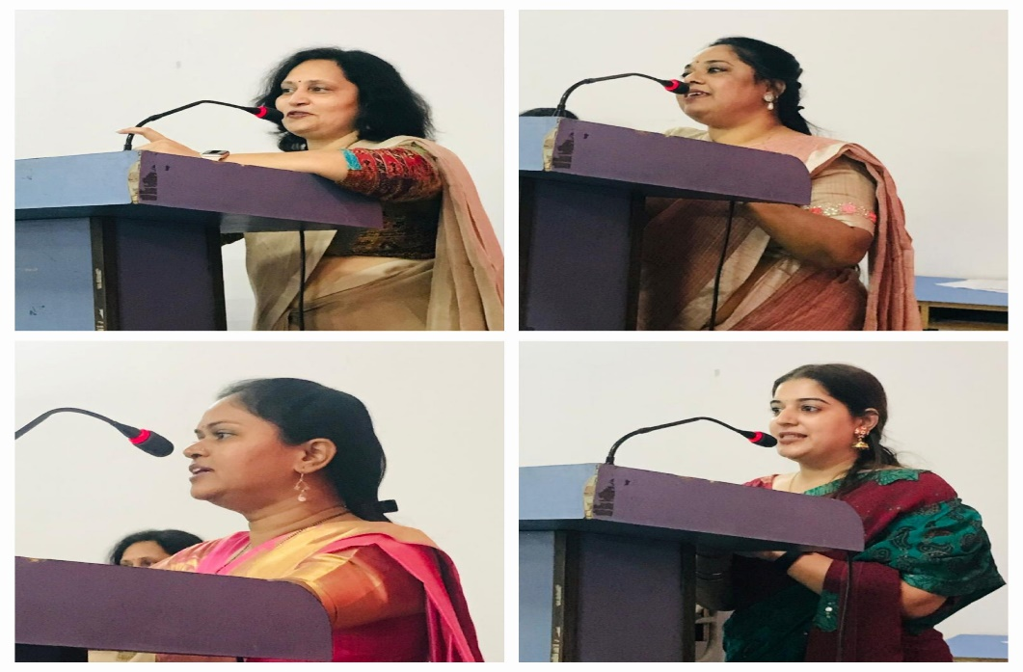
Dr. Varsha Deshpande, Dr. Pratima Lokhande, Dr. Vaishali Sukhdeve and Ms. Navjyot Sethi addressing the students.

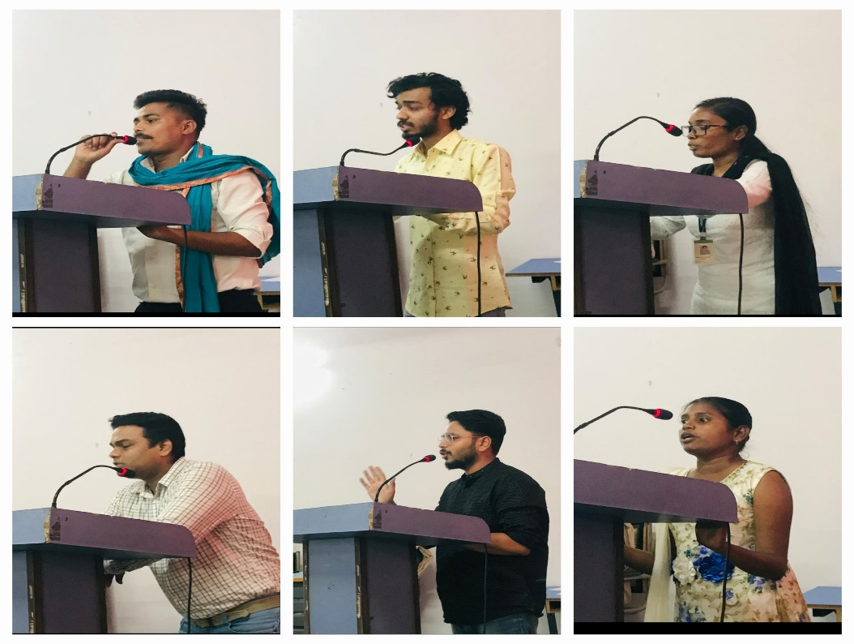
Participants reciting the poems

